THE ALTERNATIVE SCHOOL GROUP LTD

Relationships, Sex and Health Education Policy

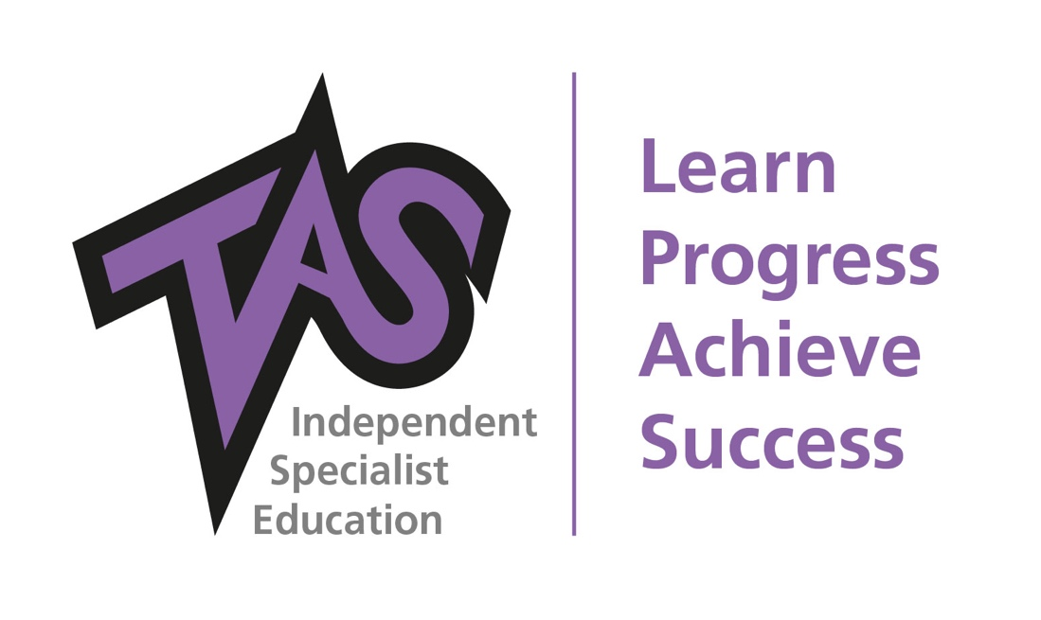

Author: | AF
Date: | 12th November 21; 23rd November 21 updated
To be reviewed: | Feb 2022
Reviewed: | Aug ’20, Feb ’20; April 21; Nov 2021
Version: | 5

Aims

The aims of relationships and sex education (RSE) at The Alternative School are to ensure pupils learn about:
- different types of relationships, including friendships, family relationships, dealing with strangers
- how to recognise, understand and build healthy relationships, including self-respect and respect for others, commitment, tolerance, boundaries and consent, and how to manage conflict, and also how to recognise unhealthy relationships;
- how relationships may affect health and well-being, including mental health;
- healthy relationships and safety on-line; and

The aims above are in line with the core expectations that we promote to all pupils: maintain a positive attitude, show respect for all and display high levels of commitment to being the best you can be. RSE plays a vital part in the school’s safeguarding obligations.

Statutory requirements

Under ‘Policy statement: relationships education, relationships and sex education, and personal, social, health and economic education’.
Secondary schools must have regard to guidance issued by the secretary of state as outlined in section 403 of the Education Act 1996.

Definition

RSE is about the emotional, physical, moral, social and cultural development of pupils, and involves learning about relationships, sexual health, sexuality, healthy lifestyles, diversity and personal identity.

RSE involves a combination of sharing information, and exploring issues and values. RSE is not about the promotion of sexual activity.

Delivery of RSE

RSE is taught within the school’s personal, social, health and economic (PSHEE) curriculum.
Biological aspects of RSE are taught within the science curriculum.

Across all Key Stages, pupils will be supported with developing the following skills:
- Communication, including how to manage changing relationships and emotions
- Recognising and assessing potential risks
- Assertiveness
- Seeking help and support when required
- Informed decision-making
- Self-respect and empathy for others
- Recognising and maximising a healthy lifestyle
- Managing conflict
- Discussion and group work

Within primary education the teaching focuses on the fundamental building blocks and characteristics of positive friendships including:
- Families and people who care for me
- Caring friendships
- Respectful relationships
- Being safe

At primary level RSE should contribute to the foundation of PSHEE and Citizenship by ensuring children:
- Develop confidence in talking; listening and thinking about feelings and relationships
- Are able to name parts of the body and describe how their bodies work
- Can protect themselves and ask for help and support
- Are prepared for puberty

Within secondary education RSE focuses on giving young people the information they need to help them develop healthy; nurturing relationships of all kinds including:
- Families
- Respectful relationships, including friendships
- Online and media
- Being safe
- Intimate and sexual relationships, including sexual health

These areas of learning are taught within the context of family life taking care to ensure that there is no stigmatisation of children based on their home circumstances (families can include single parent families; LGBT parents; foster parents/carers amongst other structures) along with reflecting sensitively that some children may have a different structure of support around them (for example: looked after children or young carers).

Roles and responsibilities

The policy committee will approve the RSE policy, and hold the Headteacher to account for its implementation.

The Headteacher is responsible for ensuring that RSE is taught consistently across the school, and for managing requests to withdraw pupils from non-statutory components of RSE (see section 6).

Staff are responsible for:
- Delivering RSE in a sensitive way
- Modelling positive attitudes to RSE
- Monitoring progress
- Responding to the needs of individual pupils
- Responding appropriately to pupils whose parents wish them to be withdrawn from the non-statutory components of RSE

Staff do not have the right to opt out of teaching RSE. Staff who have concerns about teaching RSE are encouraged to discuss this with the Headteacher.

Pupils are expected to engage fully in RSE and, when discussing issues related to RSE, treat others with respect and sensitivity. This response is in line with our core values of maintaining a positive attitude, respect for others at all times and displaying high levels of commitment.

Parents’ right to withdraw

Parents’ have the right to withdraw their children from the non-statutory components of RSE. Requests for withdrawal should be put in writing and addressed to the Headteacher. A copy of withdrawal requests will be placed in the pupil’s educational record. The Headteacher will discuss the request with parents and take appropriate action. This is only possible up to and until three terms before the pupil turns 16. At that point, if the pupil wishes to receive sex education, we will make arrangements to provide in during one of those terms.

Appropriate alternative work will be given to pupils who are withdrawn from RSE.

Training

Staff are trained on the delivery of RSE on INSET days and during CPD twilight sessions.

The Headteacher will also invite visitors from outside the school, such as sexual health professionals, to provide support and training to staff teaching RSE.

Monitoring arrangements

The delivery of RSE is monitored by the Appraisal and Supervision programme of learning walks, book scrutinies, lesson observations and pupil voice minutes as detailed in the calendar.

Pupils’ development in RSE is monitored by class teachers through the use of, “I Can ...” statements, but is not formally assessed using the 9-1 grading system.

PULSE PROGRAMME
RELATIONSHIPS AND SEX EDUCATION SECONDARY
The objective of sex and relationship education is to help and support young people through their physical, emotional and moral development. A successful programme, firmly embedded in PSHE, will help young people learn to respect themselves and others and move with confidence from childhood through adolescence into adulthood
AIMS:
It is lifelong learning about physical, moral and emotional development. It is about the understanding of the importance of marriage for family life, stable and loving relationships, respect, love and care. It is also about the teaching of sex, sexuality, and sexual health. It is NOT about the promotion of sexual orientation or sexual activity.
It has three main elements:
- attitudes and values – learning the importance of values and individual conscience and moral considerations; – learning the value of family life, marriage, and stable and loving relationships for the nurture of children; – learning the value of respect, love and care; – exploring, considering and understanding moral dilemmas; and – developing critical thinking as part of decision-making.
- personal and social skills – learning to manage emotions and relationships confidently and sensitively; – developing self-respect and empathy for others; – learning to make choices based on an understanding of difference and with an absence of prejudice; – developing an appreciation of the consequences of choices made; – managing conflict; and – learning how to recognise and avoid exploitation and abuse.
- knowledge and understanding – learning and understanding physical development at appropriate stages; – understanding human sexuality, reproduction, sexual health, emotions and relationships; – learning about contraception and the range of local and national sexual health advice, contraception and support services; – learning the reasons for delaying sexual activity, and the benefits to be gained from such delay; and – the avoidance of unplanned pregnancy.

In delivering these topics care is taken to take into consideration young males, not just young girls, ethnicity, those with special educational needs and learning difficulties and sexual identity and sexual orientation.

To cover the curriculum content outlined in the RSHEE Guidance, we will equip our pupils to build positive and respectful relationships online and offline. We seek to ensure that it gives pupils the knowledge, skills, attitudes and values that will help them to:

TOPICS | How these are delivered?
- FAMILIES including:-  - Understand family structures, committed relationships and the legal status of different types of long-term relationships  - Understand the responsibility of parenthood | Collective reflection - Relationships
- RESPECTFUL RELATIONSHIPS INCLUDING FRIENDSHIPS including  - Build self-esteem and self-worth  - Manage and explore difficult feelings and emotions (including love) | - Collective reflection: Respectful relationships  - Collective Reflection – Physical and Mental Well being  - BTEC PSD Level 1 Award, Certificate, diploma  - BTEC PSD Level 2, Award, Certificate,  - Pupil voice  - TAS Personal Development Checklist (PULSE Programme)  - Monday morning chat and brew  Access to:  - AQA Confidence Building  - AQA Life skills Mens health and wellbeing  - AQA Emotional Wellbeing
- ONLINE AND MEDIA | - Collective Reflection -Internet Safety Day  - Collective Reflection – Online and Media
- BEING SAFE including  - Consider how their choices affect their own wellbeing and that of others  - Understand and ensure the protection of their rights throughout their lives and the law regarding sexual relationships.  - Resist pressure and avoid risk taking behaviours | - Collective Reflection – Peer Pressure  - Collective Reflection – Drugs, Alcohol and Tobacco  - Collective Reflection – Staying Safe  - Agency Referral for alcohol and drug misuse and abuse  Access to:  - AQA Drugs Education and Harm Reduction  - AQA Introduction to Sex and Drugs education
- INTIMATE AND SEXUAL RELATIONSHIPS INCLUDING SEXUAL HEALTH  - wellbeing and dignity  - including contraception and safe sex | - Collective Reflection – Health and Prevention  - Guest speakers: Sexual Health  Access to:  - AQA Emotional and mental wellbeing  - AQA Life skills Mens health and wellbeing  - AQA Emotional Wellbeing
- EXPLORE AND VALUE THEIR PERSONAL/SEXUAL IDENTITY AND THE PERSONAL/SEXUAL IDENTITIES OF OTHERS | - Collective Reflection – Equality and Protected Characteristics  - Guest speaker: Chrysalis Transgender Support  - Attending Gay Pride Festival  - Creating Artwork for Pride as in FBV/SMSC

PULSE PROGRAMME
RELATIONSHIPS AND SEX EDUCATION PRIMARY
The objective of sex and relationship education is to help and support young people through their physical, emotional and moral development. A successful programme, firmly embedded in PSHE, will help young people learn to respect themselves and others and move with confidence from childhood through adolescence into adulthood
AIMS:
It is lifelong learning about physical, moral and emotional development. It is about the understanding of the importance of marriage for family life, stable and loving relationships, respect, love and care. It is also about the teaching of sex, sexuality, and sexual health. It is NOT about the promotion of sexual orientation or sexual activity.
It has three main elements:
- attitudes and values – learning the importance of values and individual conscience and moral considerations; – learning the value of family life, marriage, and stable and loving relationships for the nurture of children; – learning the value of respect, love and care; – exploring, considering and understanding moral dilemmas; and – developing critical thinking as part of decision-making.
- personal and social skills – learning to manage emotions and relationships confidently and sensitively; – developing self-respect and empathy for others; – learning to make choices based on an understanding of difference and with an absence of prejudice; – developing an appreciation of the consequences of choices made; – managing conflict; and – learning how to recognise and avoid exploitation and abuse.
- knowledge and understanding – learning and understanding physical development at appropriate stages; – understanding human sexuality, reproduction, sexual health, emotions and relationships; – learning about contraception and the range of local and national sexual health advice, contraception and support services; – learning the reasons for delaying sexual activity, and the benefits to be gained from such delay; and – the avoidance of unplanned pregnancy.

In delivering these topics care is taken to take into consideration young males, not just young girls, ethnicity, those with special educational needs and learning difficulties and sexual identity and sexual orientation.

To cover the curriculum content outlined in the RSHE Guidance, we will equip our pupils to build positive and respectful relationships online and offline. We seek to ensure that it gives pupils the knowledge, skills, attitudes and values that will help them to:
TOPICS | How these are delivered?
- FAMILIES AND PEOPLE WHO CARE FOR ME | - Monday morning chat and brew  - Collective reflection
- CARING FRIENDSHIPS | - Compulsory Qualification, 110231 AQA Emotional Wellbeing
- RESPECTFUL RELATIONSHIPS | - Collective reflection: Respectful relationships  - Compulsory Qualification, 110231 AQA Emotional Wellbeing
- ONLINE RELATIONSHIPS | - Collective Reflection – Online Relationships  - Collective Reflection -Internet Safety Day
- BEING SAFE | - Collective Reflection – Peer Pressure  - Collective Reflection – Drugs, Alcohol and Tobacco  - Collective Reflection – Staying Safe  - Agency Referral for alcohol and drug misuse and abuse  Access to:  - AQA Drugs Education and Harm Reduction  - AQA Introduction to Sex and Drugs education

