The alternative school Group Ltd

Spiritual; Moral; Social and Cultural Development Policy

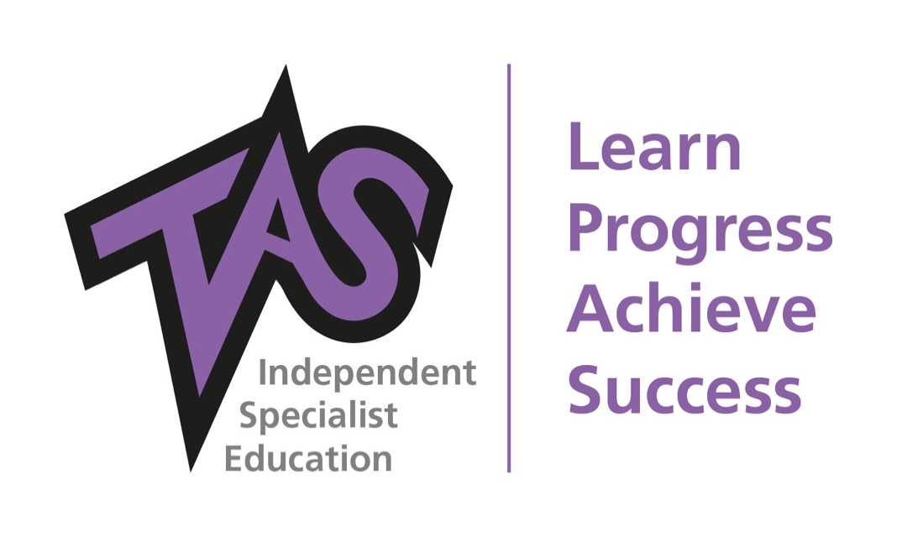

Author: | AF
Date: | 15th November 2021
To be reviewed: | Feb 2022
Reviewed: | April 21; Nov 21
Version: | 2

Introduction
At the Alternative School we recognise that for pupils to benefit from their time with us, we want to ensure that they have the best possible teaching and pastoral support, and that they must try to meet the expectations placed upon them in work, conduct and attitude. We believe that the school should actively promote all pupils’ spiritual, moral, social and cultural development by providing positive experiences through planned and coherent opportunities in the curriculum, and through interactions with teachers; other adults and their local community. As a school we recognise that the personal development of pupils, spiritually; morally; socially and culturally, plays a significant part in their ability to learn and achieve. We aim to provide an education that provides pupils with opportunities to explore and develop their own values and beliefs, spiritual awareness, a caring attitude towards other people, an understanding of their social and cultural traditions and an appreciation of the diversity and richness of the cultures. We endeavour to offer an inspiring and holistic experience to enable our young people to be responsible; reflective and active citizens with a strong awareness of modern British Values.

Implementation
The development of SMSC will be take place within the curriculum, embedded within activities that encourage pupils to recognise and reflect upon the significance of what they are learning, and to recognise any challenges that there may be to their own attitude and lifestyle. Class discussions take place through ‘collective reflection’ which provides pupils with opportunities to:
- Develop self-esteem and a respect for others
- Share thoughts and feelings with others
- Express and clarify their own ideas and beliefs
- Develop a sense of belonging
- Show empathy
- Consider the needs of others
- Explore ideas and view points
- Work co-operatively and collaboratively
- Develop the skills and attitudes that enable pupils to develop spiritually, morally, socially and culturally – e.g. respect; empathy; open mindedness; sensitivity; critical awareness etc.
Spiritual Development
Spiritual development is about a sense of identity, self-worth, personal insight, meaning and purpose. It is about the development of a pupils ‘spirit, soul, personality and character’. Pupils should develop the ability to reflect on their own beliefs, religious or otherwise, that inform their perspective on life and their interest in and respect for different people’s faiths, feelings and values. As a school we aim to provide opportunities that will enable pupils to:
- Sustain their self-esteem in their learning experiences
- Develop their capacity for critical and independent thoughts
- Foster their emotional life and express their feelings
- Allow time for reflection
- Discuss their beliefs, feelings, values and responses to personal experiences
Moral Development
Moral development is about the development of pupils’ understanding of society’s shared and agreed values, and understanding that these values can change. Pupils will have some experience of moral values which are defined by their families and friends. Pupils are encouraged to take personal responsibility for their words and actions. Pupils should have the ability to recognise the difference between right and wrong, readily applying this understanding to their own lives and, in doing so respect civil and criminal law. Pupils should develop an understanding of the consequences for their behaviour and actions. As a school we aim to provide learning opportunities that will enable pupils to:
- Recognise the unique value of each individual
- Listen and respond appropriately to the views of others
- Take initiative and act responsibly with consideration for others
- Distinguish between right and wrong
- Make informed and independent judgements
- Be able to resolve disagreements
- Learn from mistakes
- Gain the confidence to be able to cope with setbacks or disappointment
Social Development
Social development is about the young people working effectively with each other and participating successfully in the community as a whole. It is about the development of the skills and qualities necessary for living and working together, functioning effectively in a multi-cultural, multi-racial society. It involves growth in knowledge and understanding of society in all its aspects. As a school we aim to promote opportunities that will enable pupils to:
- Develop an understanding of their individual and group identity
- Discuss and display expected standards of behaviour
- Foster a sense of responsibility and community values
- Acceptance and engagement with the Fundamental British Values
- Demonstrate skills and attitudes that will allow them to participate fully and contribute positively to life in modern Britain
Cultural Development
Cultural development is about pupils’ understanding their own culture, cultures in their own local community as well as various cultures around the world. The cultural development of pupils is shown by their understanding and appreciation of the wide range of cultural influences that have shaped their own heritage and that of others. As a school we aim to promote opportunities that will enable pupils to:
- Recognise the value and richness of cultural diversity in Britain
- Be aware of and celebrate cultural diversity
- Develop an understanding of their social and cultural environment
- Recognise different religions around the world and their cultural implications

In supporting pupils’ spiritual; moral; social and cultural development we are able to actively promote British Values in ways that are appropriate for children.

