The alternative school Group Ltd

PSHEE Policy

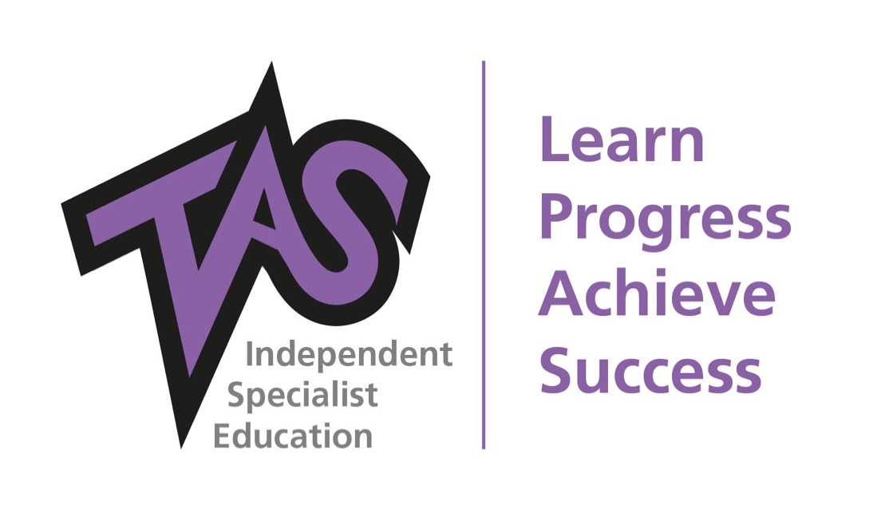

Author: | Ann Flynn
Date: | 19th November 2021
To be reviewed: | February 2022
Reviewed: | April 21, Nov 21
Version: | 2

Introduction
This policy covers our school’s approach to Personal, Social, Health and Economic Education.
PSHEE helps to give students the knowledge, skills and understanding they need to lead confident, healthy and independent lives. It aims to help them in developing personally and socially and it tackles many of the moral, social and cultural issues that affect young people in the present day world. It helps to equip pupils with an understanding of risk and the knowledge and skills necessary to make safe and informed decisions. PSHEE lessons are linked closely with ‘collective reflection’ and encompasses RSE and SMSC.
Our PHSEE programme aims to support young people to embrace change; feel positive about who they are and enjoy healthy, safe, responsible and fulfilled lives. Our learning objectives are fulfilled by the engagement of our pupils in active learning opportunities, enable students to recognise and manage risk, take increasing responsibility for themselves, their choices and behaviours and make positive contributions to their families, schools and communities.
Our PHSEE programme promotes and reflects our values of respect, equality and co-operation. Pupils learn to recognise, develop and communicate their qualities, skills and attitudes. Students accumulate knowledge, confidence and self-esteem in order to realise their true potential. As they explore similarities and differences between people and discuss social and moral dilemmas, they learn to deal with challenges and accommodate diversity in all its forms.
The world is full of complex and sometimes conflicting values. Personal well-being helps us to explore this complexity and reflect on and clarify their own values and attitudes. They identify and articulate feelings and emotions, learn to manage new or difficult situations positively and form and maintain effective relationships with a wide range of people. Personal well-being makes a major contribution to the promotion of personal development.
Education for economic well-being and financial capability aims to equip pupils with the knowledge, skills and attitudes to make the most of changing opportunities in learning and work. Through their learning and experiences inside and outside of school, pupils begin to understand the nature of the world of work, the diversity and function of business and its contribution to national prosperity. They develop as questioning and informed consumers and learn to manage their own money and finances.
We know that active engagement in learning, rather than passively receiving information, is most effective in teaching PSHEE. Pupils need opportunities to clarify their values and beliefs and rehearse and develop enquiry based, interpersonal skills.

The purpose of each lesson is made clear and linked to everyday real life situations.
Appropriate learning experiences are planned and meet the needs of all of the pupils in each class. Learning experiences draw on the pupil’s own experiences or existing knowledge and provide a range of opportunities for pupils to learn, practise and demonstrate skills, attitudes and understanding. Pupils are encouraged to take responsibility for their own learning, and time is given for pupils to reflect, consolidate and apply their learning.
All PSHEE classes develop a set of ground rules for discussions at the start of each academic year in agreement with their teacher. The aim of the ground rules is to establish an environment of respect and collaboration so that pupils feel confident in discussing sensitive issues. Teachers routinely remind pupils of the protocols in place for confidentiality. If any disclosure is made, the teacher must take the appropriate action in accordance to the school’s Safeguarding Policy. The following are protocols for discussion-based lessons with pupils:-
- No pupil or teacher will have to answer a personal question
- No one will be forced to take part in a discussion
- Meanings of words will be explained in a sensible and factual way
- Teachers may use their discretion in responding to questions and may say that the appropriate person to answer the question is the parent or carer
Where a member of staff is concerned that a child protection issue is arising, it is their duty to follow the schools Safeguarding Policy and notify the DSL.
We believe that external speakers can usefully supplement learning. We will ensure that the external agencies and contributors in put is part of a planned programme which consolidates and grows prior learning. Classes or groups are always supervised by the class teacher and other school staff.
As with any learning process, assessment of pupils personal, social and emotional development is important. It provides information which indicates pupils’ progress and achievement and informs the development of the programme. The process of assessment has a positive impact on the pupil’s self-awareness and self-esteem.
Celebration of achievement contributes to building pupils’ self-esteem, developing a sense of pride. Pupil’s achievements are recognised in ‘Celebration Friday’.
We promote the needs and interests of all pupils, irrespective of gender, culture, ability or aptitude, by creating an inclusive, safe learning environment. Teaching will take into account the ability, age-readiness and cultural background of pupils in order that all pupils can access the PSHEE curriculum. We will use PSHEE education as a vehicle to address the diversity and equality for all.

