THE ALTERNATIVE SCHOOL GROUP LIMITED

Accessibility Plan

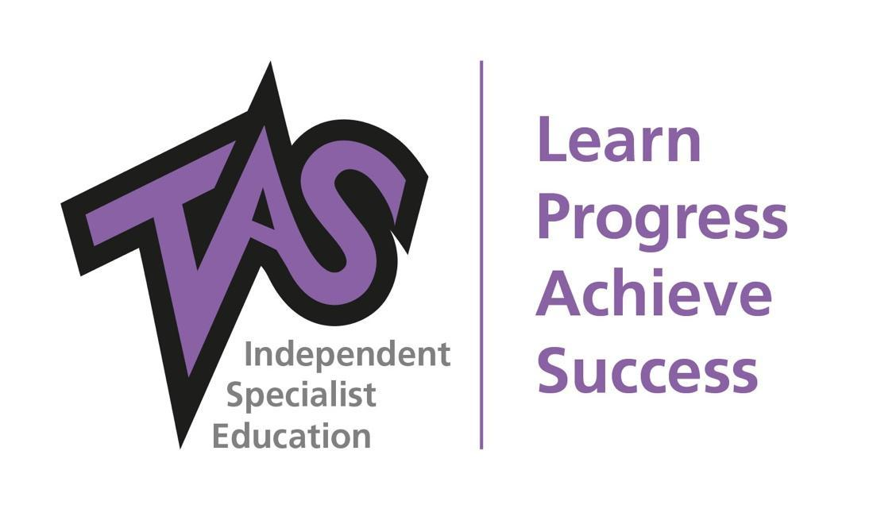

Author: | HB
Date: | 10th May 2021
To be reviewed: | July 2022, July 2023
Reviewed: | Oct ‘19, Feb ’20, June 21
Version: | 7

Introduction
This is the Accessibility Plan of The Alternative School Group Limited which addresses Schedule 10 of the Equality Act 2010 described therein as:

An accessibility plan is a plan for, over a prescribed period -

- increasing the extent to which pupils with disabilities can participate in the school's curriculum,
- improving the physical environment of the school for the purpose of increasing the extent to which pupils with disabilities are able to take advantage of education and benefits, facilities or services provided or offered by the school, and
- improving the delivery to pupils with disabilities of information which is readily accessible to pupils without disabilities.
- The delivery in sub-paragraph (2)(c) must be—
      - within a reasonable time;
      - in ways which are determined after taking account of the pupils' disabilities and any preferences expressed by them or their parents.

Context:

The Alternative School Group Limited is a non-denominational independent school for boys and girls aged from 5 - 18 years who, for various reasons, are not accessing mainstream education.

The school aims to provide an alternative experience for those young people in the area who are not attending mainstream provision. We are committed to providing a secure environment in which every pupil can access a broad curriculum. Using a holistic approach we support both the personal and educational needs of young people, helping them to overcome a wide range of barriers to learning, and to develop themselves into confident, articulate and well-rounded young individuals who leave school with a range of appropriate qualifications and a clear transition plan to further education and/or training.

TAS ensures every pupil is given the chance of an education through our Ethos, Culture, School Charter, Personal and Social Development and our personalised approach to all pupils and staff.

Our Inspiration and Vision:

This policy is developed in line with Our Inspiration and Vision that:

The Alternative School Group Limited is inspired by a belief that we can make a difference to every young person we work with by listening to them and raising their aspirations. We believe in the potential of every young person, no matter who they are, what they have done or what they have been through and in line with the TAS strategy of Our 5 Principles to:

Support, Educate, Encourage Independence, Inspire and Motivate and Partnership Working.

Identification and Assessment
TAS is committed to assessing and identifying the needs of all pupils to ensure every pupil can access an education and to ensure all needs are met. We do this by:
- An open referral policy with no discrimination
- An induction period in which each pupil undertakes a thorough Initial Assessment Process which includes our ten point assessment which gathers both qualitative and quantitative data and pupil information from a range of multi agencies, previous secondary and primary provisions and from local authorities.
- TAS assesses reading age, spelling age, literacy and numeracy levels and cognitive ability.

The statements below define the activities we will undertake in pursuit of our vision
We will:

- Create and deliver an alternative curriculum for young people which is innovative, holistic and then supports and encourages positive progression and promotes independence
- Provide advice and support to young people, signposting to other agencies whilst hand-holding through this process
- Work only with organisations which work with young people to ensure they are listened to and their individual needs met
- Ensure all objectives detailed are part of our School Development Plan.

Policy Statement:

The aim of this plan is to ensure that no pupil is treated less favourably for a reason related to their disability. Reasonable adjustments are made for pupils with additional needs so that they are not at a substantial disadvantage and that access to education for pupils with disabilities is increased.
This plan sets out the proposals of the Proprietor and the TAS Advisory Board to increase access to education for pupils with disabilities in the three areas required by Schedule 10 of the Equality Act 2010:
- To increase the extent to which pupils with disabilities can participate in the school's curriculum
- To improve the physical environment of the school for the purpose of increasing the extent to which pupils with disabilities are able to take advantage of education and benefits, facilities or services provided or offered by the school
- To improve the delivery to pupils with disabilities of information which is readily accessible to pupils without disabilities.
And further:

- To develop the skills, knowledge and understanding of all staff in the teaching of pupils with disabilities through on-going CPD
- To promote a safe, caring, tolerant and friendly environment within the School where good behaviour and education are valued and where pupils treat one another and the school staff with respect.

It is a requirement that the School’s accessibility plan is resourced, implemented and reviewed and revised as necessary. Attached is a set of action plans showing how the school will address the priorities identified in the plan.

Accessibility Plan - previously known as DDA 2-year Policy – ongoing from July 2021 to Sept 2024 (to be reviewed July 2022, July 2023)

Objective – in addition to ensuring all other policies. All teachers and staff to consider Disability  Access issues | Action | By when? | By whom? | Resources | Success Criteria | Monitoring & Review Dates
1. Identification and  Assessment  To understand the needs of pupils and ensure information is available, by ensuring that all pupils are assessed with a 10 point assessment following induction. | - 10 point assessment to be incorporated into staff training in 22nd, 23rd July 2021 and to form part of ALL pupil first half terms. | July 21  Sept 21 | KP to train all team at inset 22nd,23rd July 21.  KP to train Heads and how to monitor and track | KP Time  Training venue | 10 point assessment on each pupil folder on Dropbox. | AF to monitor as part of audit process.
Objective | Action | By when? | By whom? | Resources | Success Criteria | Monitoring &  Review Dates
2. Access to Curriculum  - To ensure access to computer technology appropriate for pupils with disabilities and in line with TAS E Safety Policy.  - To ensure all pupils can participate in the curriculum and further develop a wider curriculum of adventurous activities and enrichment programmes.  - To plan for disabled transport with tail lift to enable access to activities.  - Allocate a staff champion in each campus to ensure we are working to dyslexia guidelines for all pupils and staff and achieve Dyslexia Friendly Accreditation.  - Training for teachers on differentiating the curriculum for disabled children as required, | - KP to authorise Budget  - KS to form ESafety team  - MW to set up IPAD system and trading staff  - Head teachers to research activity providers, visit and set up an activity plan for each campus.  - Plan & development DofE voluntary & expedition activities  - Contact and organise a programme of guest speakers/specialist d  - Source new vehicle when updating campus vehicles.  - Train staff . Full audit in each campus.  - Inset training | Sept 21  Nov 21  March 21  April 21  July-Sept 22  Dec 21  Sept 21 | KP  KS  MW  Heads  T B  MW/CW  TM  SENCO  KS/KP | Budget  Inset Venue  July 22nd  Time, in Heads Dev Days  Time, out of school to explore  Time  Budget agreed with KP, PKnowles  INSET time, Training Budget.  Budget for resources, relevant books.  Time allocated | IPADS used to access extended learning curriculum and CSI training videos  Improved behaviour, engagement and outcomes for pupils.  New Vehicle  Dyslexia Friendly Accreditation achieved & demonstrated in all  classrooms & lessons  Teachers are able to more fully meet the requirements of disabled children’s needs with regards to accessing the curriculum. | AF to monitor as part to TL&A audits  Pupil Voice Feedback  Parent Questionnaires  AF to include in audit.  Report to advisory board.  AF to include in audit  SENco to monitor  AF to monitor as part of audit process
Objective | Action | By when? | By whom? | Resources | Success Criteria | Monitoring &  Review Dates
3. Newsletters and Documents  To develop the availability of newsletters and school documents for parents in alternative formats such as large, studio and Braille. | Alternative, e.g. large print and audio formats, etc. available.  Allocate responsibility of documents in alternative formats & review accessibility of newsletter and letters for parents/carers  Newsletter, Policies, Home/School Communications, etc. available on the School’s updated website  All communication to be sent using dyslexia friendly colours, between schools, agencies and parents. All staff to be trained. | March 2022  Sept 2022  Nov 2022  Nov 2022 | Comms  JS  TM  Comms | INSET Training  Allocate new job role (July 21)  Allocate time in TM Joni role  Comms training/development day | Newsletters & other documents accessible to parents/carers  Questionnaire results & feedback from parents, referring schools and other agencies  Website information appropriate & accessible  Evidence in use, files, dropbox , feedback. | AF to monitor as part of audits

Objective |  |  | Action |  | By when? |  | By whom? |  | Resources | Success Criteria |  | Monitoring &  Review Dates
 | - School Buildings  - To ensure that access to the school buildings and site can meet the diverse needs of pupils, staff, parents/carers and community users with wheelchair access and egress.  - To ensure adequate first aid space to meet the needs of all pupils, 5-18 yrs. | - Audit of each TAS building with Lee Stansfield, TAS linked architect.  - Produce an action plan in line with local planning guidance and national policy  - Support KP,AF with obtaining appropriate planning and quotes.  - Audit of each campus  - Allocation of temporary first aid area close to WC, with first aid bed and rail  - Meeting with Lee Stansfield, link architect |  | Audit by Nov 21  Action Plan by Feb 22  Planning, quotes March-July 22  Further action Sept 22-Dec 22  Aug 21 |  | KP, AF  AF  KP  LS |  | Budget  Budget |  | All TAS campuses accessible  Compliant First Aid  Area | AF to audit  Advisory Board John Clayton to support and audit  AF & AH to include in compliance audit

Objective | Action | By when? | By whom? | Resources | Success Criteria | Monitoring &  Review Dates
5. Classrooms  To ensure that classrooms are optimally organised for pupils with disabilities within current restraints  To identify needs and actions for future improvements | - Plan classroom layout in accordance with pupil need  - Organise resources accordingly  - Include kitchen area to develop healthy lifestyles/independence  - Provide quiet study area  - Computer area  - Additional SEN equipment such as noise protectors  - Introduce/meditation /mindfulness room area for use 1 at a time. A peaceful, calm environment with a bean bag, no hard furniture, mindfulness colouring and equipment to play music | Sept 21 | Heads & lead Teachers  Senco | Budget  SEN Training | Classrooms re- decorated and re- furbished in line with agreed TAS ‘pupil friendly’ classroom design | AF Audit  Ongoing classroom audits (SLT)  School Council, Team & SLT Meetings  HT Report to TAS Advisory Board  Risk assessments  KS Assessment

Objective | Action | By when? | By whom? | Resources | Success Criteria | Monitoring & Review Dates
6. Impact Analysis  To ensure all policies consider the implications of Disability Access | - Analyse impact of Behaviour Policy & Procedures, School Rules, Anti-Bullying Policy, Educational Visits, Homework and Health Provision, etc. in relation to pupils with disabilities  - Involve School Council in all reviews  - Consult pupils and staff on any proposed changes  - Introduce new and updated policies as required Comply with all current legislation | Sept 22 | School Council Lead SLT &  Teaching Staff at each campus  SLT  SENCo | Leadership Team, and SENCo time to review policies | Current & appropriate policies & procedures in place, all considering disability access.  Pupils and staff involved in the process and understand current policy & practice | Ongoing per yearly policy review dates or more if legislation requires.  HT Report to TAS Advisory Board  Liaison & review with Board Member with responsibility for School policy & practice including Safeguarding

Objective | Action | By when? | By whom? | Resources | Success Criteria | Monitoring &  Review Dates
7. Attitudes  To promote positive attitudes to disability | - Review PSD Curriculum Review Friday Celebrations  - Review Collective Reflection/Theme of the Week Programme  - Regular items for newsletter highlighting achievement of pupils with disabilities  - Allocate staff champion in each campus | Jan 22 | KS & AF | Meeting & Planning time  Dedicated time to produce collective reflection booklets  Dedicated time to produce half- termly newsletter | PSD programme, assemblies & Collective Reflection promotes & reflects the School’s commitment to developing positive attitudes to disability & diversity  Trained staff per centre to promote knowledge in teaching in this area. | AF Audit  Feedback from teaching staff and pupils including PSD tracker data (termly)  Feedback from parents/carers, referring schools and outside agencies  HT Report to TAS Advisory Board Liaison & review with Board Member with responsibility for  Curriculum  Monitored through evidence and training.

Aspects of Policies relevant to Disability Admissions and pupils with disabilities

We are an inclusive school with an ‘open door’ Admissions Policy and we welcome all young people who can make the most of the opportunities that we offer and can flourish in the caring environment of The Alternative School. Treating every child as an individual is important to us. We will not discriminate on any grounds, previous history or special need that a young person may have and we welcome pupils with physical disabilities provided that they can cope with our site(s).

We advise parents/carers of children with physical disabilities to discuss their child’s requirements with the Headteacher before he or she views the facility so that we can make adequate provision for him/her. Parents/carers should provide a copy of a medical report to support their request, for example, for large print material or other special arrangements.

On Entry

Each pupil with a disability requires special consideration and treatment and, if appropriate, adjustments will need to be put in place. We will discuss thoroughly with parents/carers and their medical advisers the adjustments that can reasonably be made for their child once they have accepted the offer of a place and before he/she becomes a pupil at the school. We recognise that some pupils with disabilities may also require specialist support and we would normally discuss this issue with parents/carers before their child enters the school. Copies of The Alternative School’s Special Educational Needs Policy may be downloaded from our website.

Physical Accessibility

Current or prospective parents/carers of disabled children may also wish to obtain copies of our Accessibility Plan from the web site. This shows the ways in which we plan to make our buildings, provision and resources progressively more accessible to pupils with disabilities, parents/carers and visitors. The Alternative School has an active monitoring ethos and will do its best to make adjustments to take account of an individual pupil’s needs, within the constraints imposed by our buildings.

Other Adjustments

We are able, depending on need, to arrange for pupils to use laptop computers in classes, and, for example, for large print documents to be given to those with impaired vision.

Medical Provision

The Alternative School has rigorous Medical and First Aid Policies and Procedures in place and we have appropriately trained first aiders on each of the sites with specific responsibilities for First Aid.

Monitoring, Review and Training

Who is responsible for implementing the plan?

The Proprietor, The TAS Advisory Boards, The Compliance Manager, The Headteachers, Senior Leadership Team (SLT) and all staff.

Monitoring and Success Criteria

This plan is regularly monitored and reviewed via Heads Meetings, SLT Meetings, weekly Team Meetings, daily, weekly, monthly and termly health and safety checks, including rigorous individual, classroom, generic and site specific risk assessments, health and safety and building/classroom audits and developments and liaison with and reports to the TAS Advisory Board.

Staff Training

Our aim is for all teaching staff to receive training on the learning needs of pupils with special educational needs and disabilities. All staff (including teaching and support staff) are given regular training on working with pupils with additional needs. HR keep an appropriate log of our INSET and CPD training for all staf

